### **BACHELOR OF TECHNOLOGY**

**SYNOPSIS OF**

**RESTAURANT BOOKING WEBSITE**

**SUBMITTED BY**

STUDENT NAME

University ID

Year of Admission

Branch (indicate Integrated/Modular)

**Supervised by**

NAME OF GUIDE

*Designation*

Department/School of the guide

Logo of college

**CHITKARA UNIVERSITY**

PUNJAB, INDIA

**CERTIFICATE**

**Candidate's Declaration**

I hereby declare that the work presented in this report entitled “Restaurant Booking Website” in partial fulfillment of the requirements for the award of the degree of Bachelor of Technology in Computer Science and Engineering/Information Technology submitted in the department of Computer Science & Engineering and Information Technology, Jaypee University of Information Technology Waknaghat is an authentic record of our own work carried out over a period from August 2016 to May 2017 under the supervision of Dr. Pardeep Kumar, Assistant Professor (Senior Grade), Computer Science and Engineering & IT.

The matter embodied in the report has not been submitted for the award of any other degree or diploma.

**Your Name, Roll No**

This is to certify that the above statement made by the candidate is true to the best of my knowledge.

**(HOD)**

**Computer Science and Engineering Department**

**Dated:**

**ACKNOWLEDGEMENT**

We owe our insightful appreciation and gratitude to our project supervisor **(HOD Name)**, who took keen interest and guided us all along in the project work, titled ―“ **Restaurant booking website .”**, till the completion of the project byproviding all the necessary information for developing the project. The project development helped us in research and we got to know a lot of new things in the domain of Data Analysis. We are in truth grateful to him.

Your Name, Roll Number

Date:

**TABLE OF CONTENT**

**CERTIFICATE……………………………………………………………...**

**ACKNOWLEDGEMENT…………………………………………………..**

**ABSTRACT…………………………………………………………….......**

* 1. Introduction…………………………………………
  2. Objective…………………………………………
  3. About front end technologies………………………………………
  4. Backend............
  5. scope…………………………
  6. Implementation process..............
  7. screenshots........

**CONCLUSION……………………………………**

**REFERENCES…………………………………**

**Abstract**

The project is of web designing using Html, Css, Bootstrap and JavaScript for frontend. The purpose of designing this website to is provide the online booking of restaurant to the user. And the user can see the various Menu that is available in the online restaura website. This is the portal where firstly user have to register and after login. and see the various categories of food items according to need of user. It is responsive website and it include the various categories of foods. User can book the parties like private parties, family parties and custom parties. User can also see the chefs of restaurant and see their testimonials. The services that are provided is food ordering and reservation table management by the customer through the system online, customer information management and waiter information management, menu information management and report. Main objective build the system this is to provide ordering and reservation service by online to the customer. With this system online, ordering and reservation management will become easier and systematic to replace traditional system where are still using paper.

**Web development for frontend**

Web development refers in general to the tasks associated with developing websites for hosting via intranet or internet. The web development process includes web design, web content development, client-side/server-side scripting and network security configuration, among other tasks.

In a broader sense, web development encompasses all the actions, updates, and operations required to build, maintain and manage a website to ensure its performance, user experience, and speed are optimal.

It might also, but not necessarily, include all those strategic actions needed to ensure its proper ranking on search engine results. Usually, those tasks pertain to a different specialization, namely search engine optimization (SEO)

**Role of HTML in web development**

Hypertext Mark-up Language, or HTML, is a [001](https://generalassemb.ly/education/front-end-web-development-remote-online) used to describe the structure of information on a web page. Together, [HTML, CSS, and JavaScript](https://generalassemb.ly/education/front-end-web-development) make up the essential [building blocks of websites](https://generalassemb.ly/education/front-end-web-development-remote-online), with [CSS](https://generalassemb.ly/coding/front-end-web-development/css) controlling a page’s appearance, and [JavaScript](https://generalassemb.ly/education/javascript-development-remote-online) programming its functionality. You can think of HTML as providing the bones of a web page, while CSS provides the skin, and JavaScript provides the brains.

A web page can contain headings, paragraphs, images, videos, and many other types of data. [Front-end developers](https://generalassemb.ly/education/front-end-web-development-remote-online) use HTML elements to specify what kind of information each item on a web page contains — for instance, the “p” element indicates a paragraph. [Developers](https://generalassemb.ly/education/front-end-web-development-remote-online) also write HTML code to specify how different items relate to one another in the overall structure of the page.

Every website you open in your [browser](https://generalassemb.ly/coding/front-end-web-development/web-browsers), from social networks to music services, uses HTML. A look under the hood of any website would reveal HTML code providing structure for all the page’s components.

**Role of css in web development**

Cascading Style Sheets, commonly known as CSS, is an integral part of the [modern web development process](https://www.plasmacomp.com/blogs/the-process-of-launching-a-successful-web-app-development-project). It is a highly effective [HTML](https://www.plasmacomp.com/blogs/5-reasons-why-htm5-is-the-future-of-web-design) tool that provides easy control over layout and presentation of website pages by separating content from design.

The standout advantage of CSS is the added design flexibility and interactivity it brings to web development. Developers have greater control over the layout allowing them to make precise section-wise changes.

As customization through CSS is much easier than plain HTML, web developers are able to create different looks for each page. Complex websites with uniquely presented pages are feasible thanks to [CSS](http://www.w3schools.com/css/).

CSS works by creating rules. These rules are simultaneously applied to multiple elements within the site. Eliminating the repetitive coding style of [HTML](http://www.w3schools.com/html/) makes development work faster and less monotonous. Errors are also reduced considerably.

Since the content is completely separated from the design, changes across the website can be implemented all at once. This reduces delivery times and costs of future edits.

Improved website loading is an underrated yet important benefit of CSS. Browsers download the CSS rules once and cache them for loading all the pages of a website. It makes browsing the website faster and enhances the overall user experience.

**Role of bootstrap in web development**

Bootstrap allows back-end developers the ability to pseudo-implement layouts without the need for a front-end developer. It gives people who don’t know much about how CSS works an easy way to implement basic grid structures for modules and full-page layouts. It is a great tool for rapid prototype development.

Unfortunately, it’s now being used in production environments as a crutch by many “front-end developers” who don’t know how to build a grid on their own

Bootstrap is a user interface framework written in CSS and JavaScript. It has various widgets that make developing a front-end faster and easier. Some widgets are static (like toolbars and themed buttons) and some are dynamic (like modal dialog boxes and interactive image galleries). The dynamic ones require jQuery. It also comes with a lot of utility classes to make common CSS tasks easier.

It’s not the only game in town. Competitors include Material (from Google), Semantic UI, Clarity (from VMWare), etc.

**Role of JavaScript in web development**

In front-end web development, JavaScript is one of three major elements that are needed to end up with a web page that can be rendered properly. The other two are [**CSS**](https://www.smartsites.com/blog/familiarize-sizing-css-layouts/) and HTML. HTML is the most basic of this and is used to design the overall structure and content of the site. CSS, on the other hand, is a powerful tool that can be used to make the site more aesthetically friendly and can also have a minimal impact on interactivity.

JavaScript’s major role is to provide a platform for making the website more interactive, such as by creating dropdown menus and forms.

* 1. **Project Background:**

Restaurant Booking is the system for manage the restaurant business. The main point of developing this system is to help restaurant administrator manage the restaurant business and help customer for online ordering and reserve table. The project is developing because; many restaurants have a lot difficult to manage the business such as customer ordering and reservation table. By using manual customer ordering is difficult to waiter keep the correct customer information and maybe loss the customer information. So, online restaurant management system will develop to help the restaurant administrator to manage restaurant management and for customer make their online ordering and reservation table. Other than that, this project is to upgrade the manual system and make the business easily to access and systematic.

* 1. **Problem Statement:**

Nowadays, many restaurants manage their business by manual especially take customer ordering. Today, restaurant waiter takes the customer ordering by manual system with using paper. This is problem for restaurant waiter the probability lost and duplicates customer information. Additionally, it would affect to reputation restaurant in operate management of ordering. hides, the restaurant waiter information also by manual system kept use paper and this is difficult for restaurant administrator to find waiter information, probability missing the paper and difficult to arrange the schedule. Sometimes, waiter information and customer information is important to restaurant administrator for reference in the future. Furthermore, restaurant side needs management in the section menu. This is the important to restaurant waiter to manage the menu. Besides this section is for customer viewer the menu that restaurant prepared and make their ordering. As a result, the current system (manual system) is not effective and efficient to use anymore because the current system cannot save, manage and monitor the restaurant waiter information, menu info, customer ordering info. and generate report well.

**1.3 Objective:**

Based on the problems stated above, the objectives of the project are:

1. to develop online ordering and reservation system in restaurant.

11. to develop use interface for online restaurant management system

iii. to provide online menu information for customer

* 1. **Scope:** This section consist of three components which is target user, target area and project deliverables.

**1.4. Target User** The groups of user that had been identified to use the system are customer and administrator.

**1.5 project significance**

This is system will be going to help customer and administrator in restaurant especially part of online ordering and reservation table. Most of restaurant has a problem of the ordering and reservation table. The result of online ordering and reservation table will give customer easy to make ordering and reservation table online and hopefully can smoothen up the job of administrator and waiter. This system also produces a computerized system in defining the best solution in each ordering and reservation problem faces by customer and administrator.

1**.6 Expected Output**: The expected output from this project is a system-- that will be able to store customer's information, waiter's information, menu's information, store customer information of online ordering and reservation information and customer's suggestion and generate profit business report. Other-wise this system will change form manual system to computerized system.

**Role of front-end languages for the web development**

How Is Web Development Divided?

Web development is often separated into front-end development and back-end development. If you are working as a freelancer, you could need to complete both of these roles. If you are part of a larger team, you’ll probably just be focused on one aspect.

**Front-End**

Front-end development is based on programming languages which can include HTML, JavaScript, and CSS. When you research web development, you might find that developers favour a particular language and suggest that this one is the best. However, that’s not the case and the individual languages all have different roles to play. Which one you use will depend on the project that you are working on.

As a front-end developer, you’ll be focused on connecting the dots between design and the technology behind it. While web designers will focus on the visuals of a site, the web developer works to transform these designs. Key aspects include:

* Layout
* Buttons
* Navigation
* Internal links

For instance, if you are working on navigation you might need to explore best testing tools. This will ensure that users can easily find core pages on the website and that they don’t get lost down the rabbit hole of endless links. Developers have to test various aspects of site usability and ensure that everything is functioning as it should.

**Back-End**

This refers to the server-side element of development. If you’re working as a back-end developer, then you won’t have any connection to the visuals or the design of the website. However, the role is just as important. You will need to update the website and make the right changes. It will also be necessary for you to constantly change the website is functioning as it should and remains effective.

Back-end developers are required to write code. This code is used to communicate information from the database to the browser. You do need to be familiar with the language front-end developers are using to ensure that this does work effectively. However, you will also need to understand other coding languages as well.

So, while front-end developers focus on the holistic side, back-end developers looking at whether the site is functioning correctly. Back-end languages can also be used to create dynamic sites.

When you’re part of this aspect of development, you will need to make sure that you understand the goals of a website owner or app owner and work to bring them to fruition. You will also need to make sure that information on the site is displayed correctly for the end-user.

**Modules of the project:**

**Home page:** the home page includes all the links for another pages to navigate on. Home page contain the links of register, login, menu, chefs and about us and contact us by using which user can navigate to any pages he/she want to move. Home page is the first page that is loaded when you open the website.

**Login:** The login page is used to login the user. User can login on the restaura website by clicking on the login link. When the user clicks on the login link a login form will be opened and if the user enters the valid credentials in the login form, then only user can login into the site otherwise the authentication message will be displayed in the case if user enters wrong email id and password in input fields of the form.

**Menu:** The menu includes all categories of food available in the restaura. all the food items are categorized properly with respective price details and discounted offers are also available on the various food items. The menu will be present for both parties as well as customers of restaura.

Menu is designed according to the foreign style dishes and Indian dishes.

**PHP for the backend:**

The **PHP Hypertext Preprocessor (PHP)** is a programming language that allows web developers to create dynamic content that interacts with databases. PHP is basically used for developing web based software applications. This tutorial helps you to build your base with PHP.

Why to Learn PHP?

**PHP** started out as a small open source project that evolved as more and more people found out how useful it was. Rasmus Lerdorf unleashed the first version of PHP way back in 1994.

**PHP** is a MUST for students and working professionals to become a great Software Engineer specially when they are working in Web Development Domain. I will list down some of the key advantages of learning PHP:

* PHP is a recursive acronym for "PHP: Hypertext Preprocessor".
* PHP is a server side scripting language that is embedded in HTML. It is used to manage dynamic content, databases, session tracking, even build entire e-commerce sites.
* It is integrated with a number of popular databases, including MySQL, PostgreSQL, Oracle, Sybase, Informix, and Microsoft SQL Server.
* PHP is pleasingly zippy in its execution, especially when compiled as an Apache module on the Unix side. The MySQL server, once started, executes even very complex queries with huge result sets in record-setting time.
* PHP supports a large number of major protocols such as POP3, IMAP, and LDAP. PHP4 added support for Java and distributed object architectures (COM and CORBA), making n-tier development a possibility for the first time.
* PHP is forgiving: PHP language tries to be as forgiving as possible.
* PHP Syntax is C-Like.

Characteristics of PHP

Five important characteristics make PHP's practical nature possible −

* Simplicity
* Efficiency
* Security
* Flexibility
* Familiarity

**Applications:**

As mentioned before, PHP is one of the most widely used language over the web. I'm going to list few of them here:

* PHP performs system functions, i.e. from files on a system it can create, open, read, write, and close them.
* PHP can handle forms, i.e. gather data from files, save data to a file, through email you can send data, return data to the user.
* You add, delete, modify elements within your database through PHP.
* Access cookies variables and set cookies.
* Using PHP, you can restrict users to access some pages of your website.
* It can encrypt data.

## Audience

This **PHP tutorial** is designed for PHP programmers who are completely unaware of PHP concepts but they have basic understanding on computer programming.

## Prerequisites

Before proceeding with this tutorial you should have at least basic understanding of computer programming, Internet, Database, and MySQL etc is very helpful.

In order to develop and run PHP Web pages three vital components need to be installed on your computer system.

* **Web Server** − PHP will work with virtually all Web Server software, including Microsoft's Internet Information Server (IIS) but then most often used is freely available Apache Server.
* **Database** − PHP will work with virtually all database software, including Oracle and Sybase but most commonly used is freely available MySQL database.
* **PHP Parser** − In order to process PHP script instructions a parser must be installed to generate HTML output that can be sent to the Web Browser. This tutorial will guide you how to install PHP parser on your computer.

**Coding screenshots:**

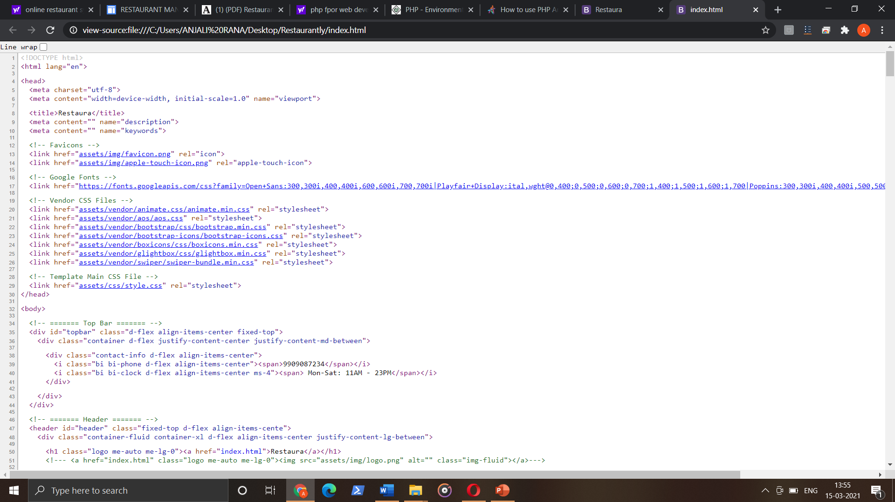

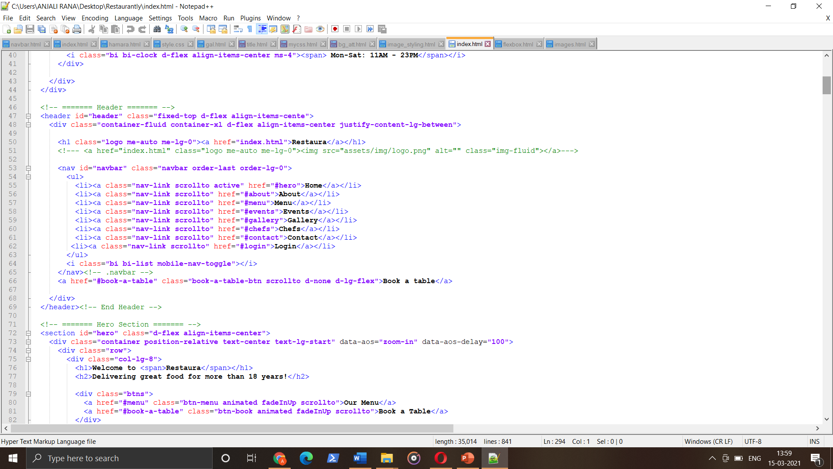

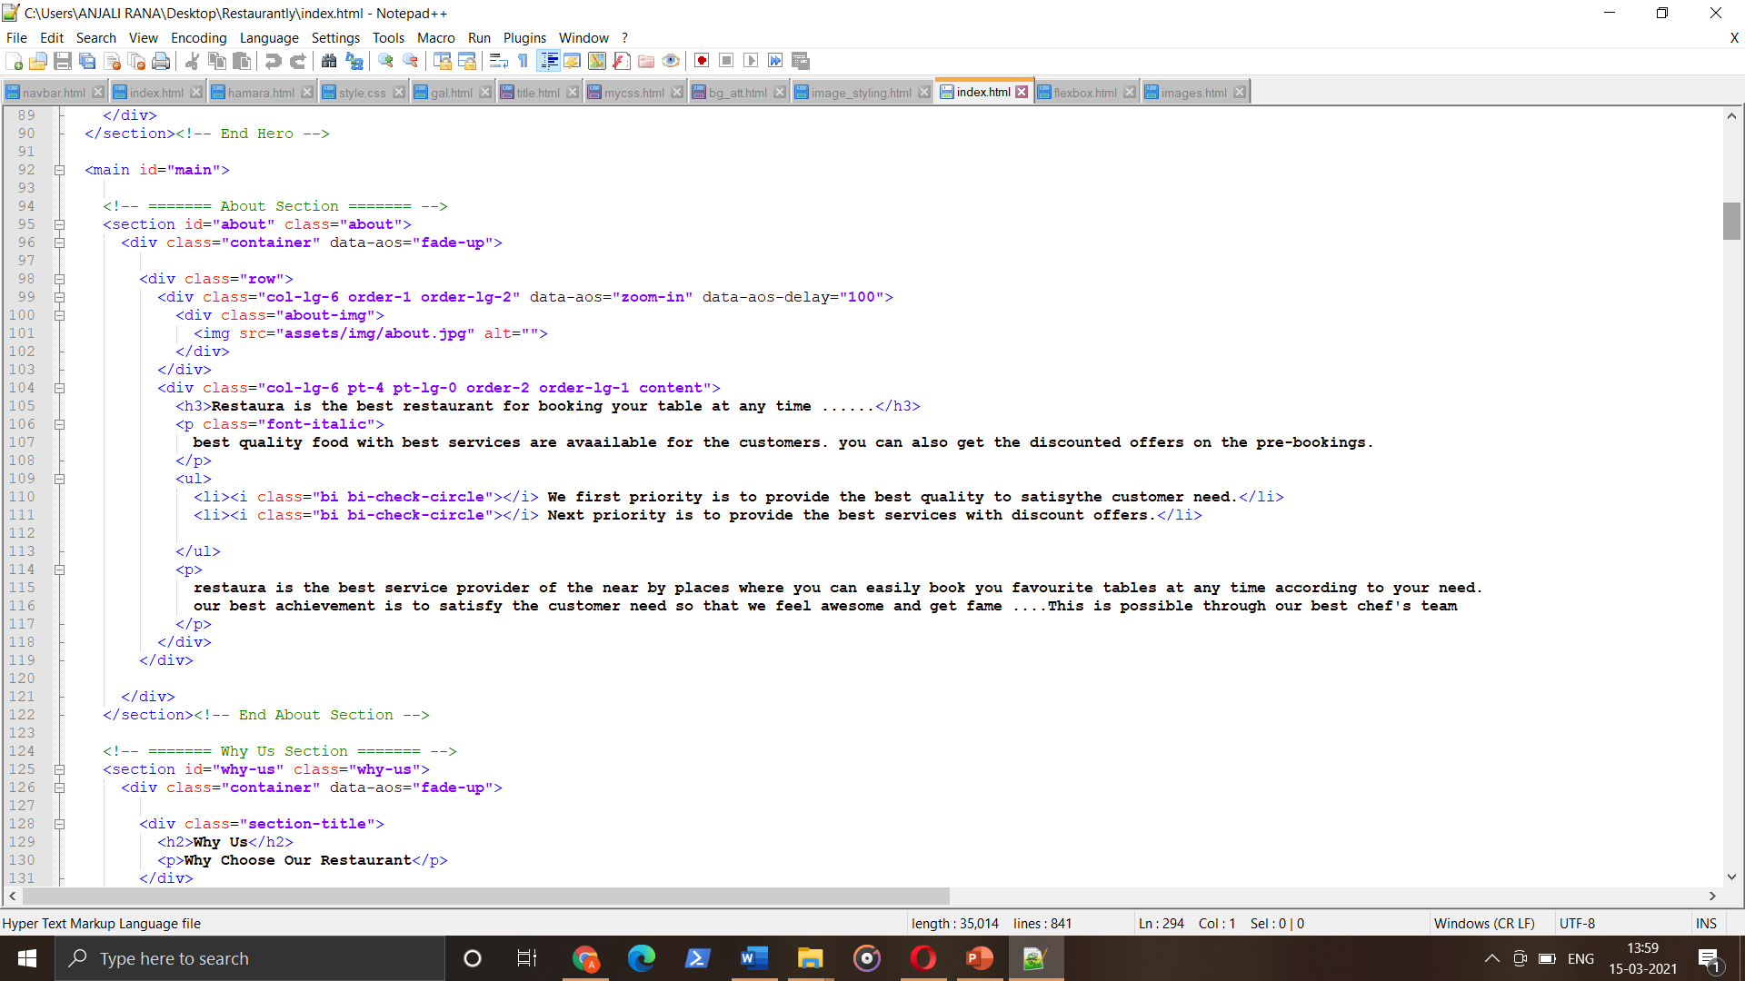

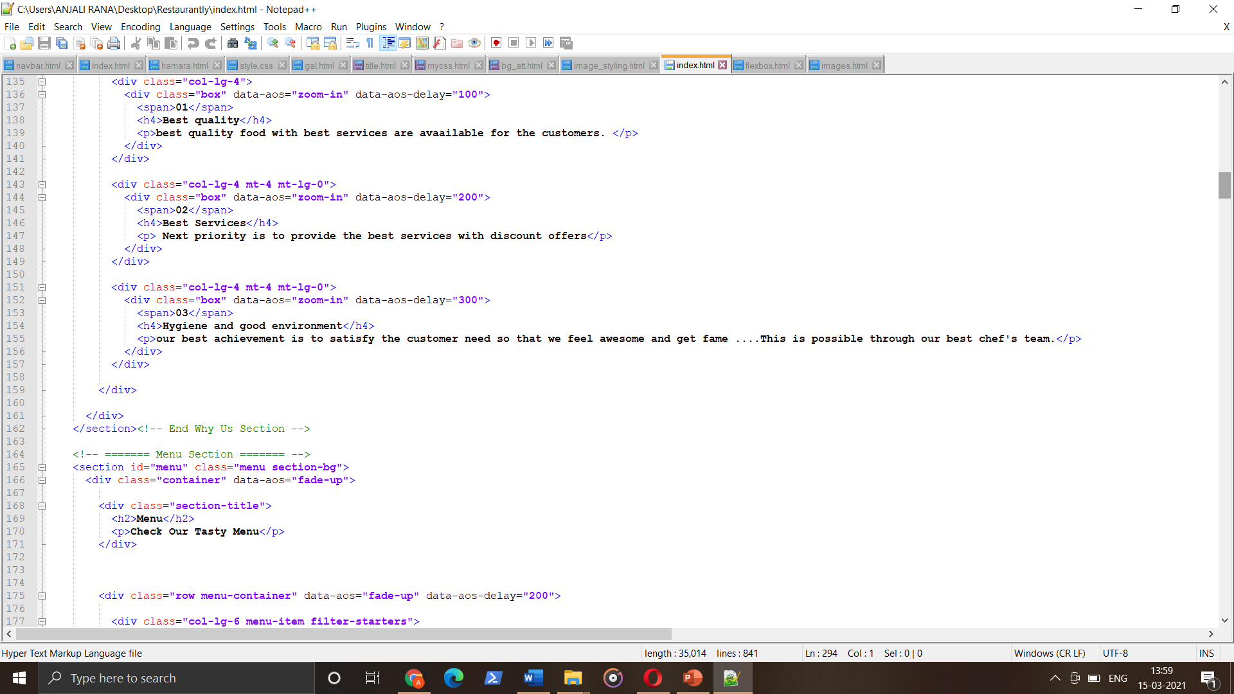

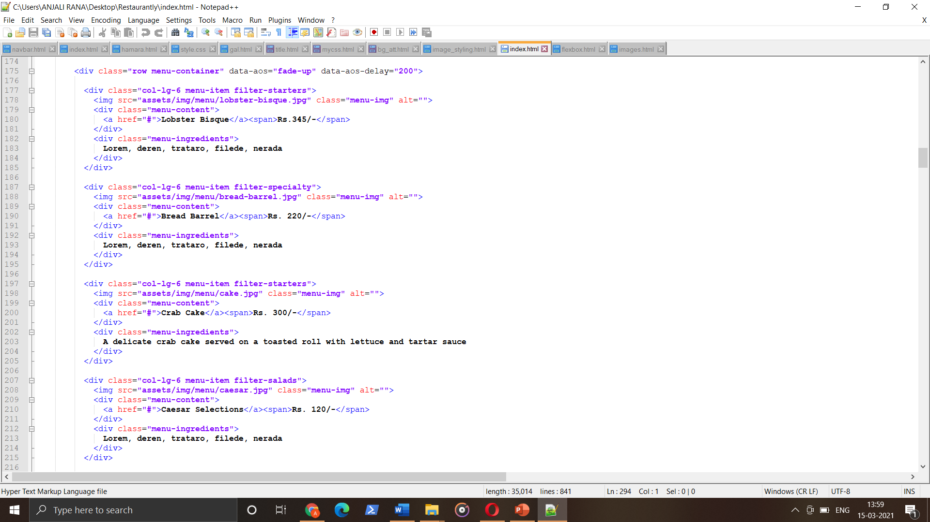

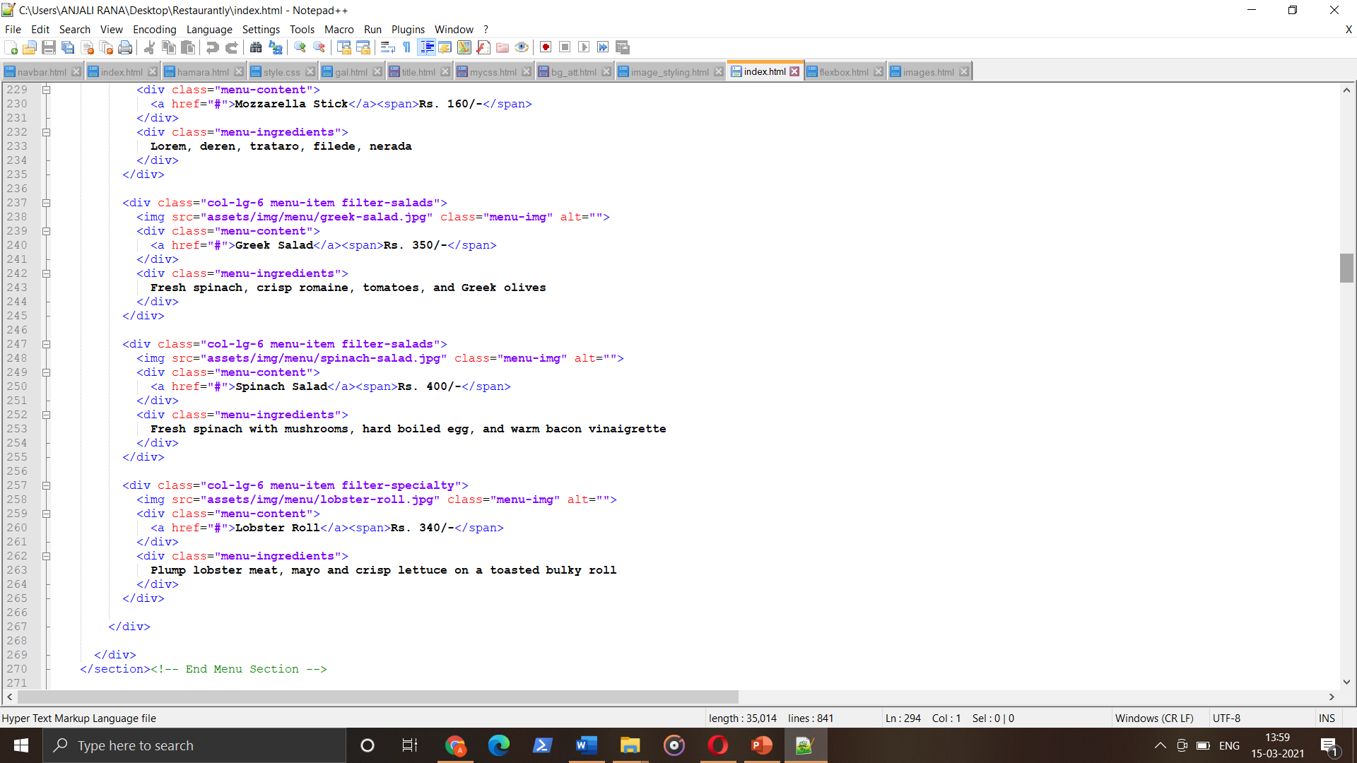

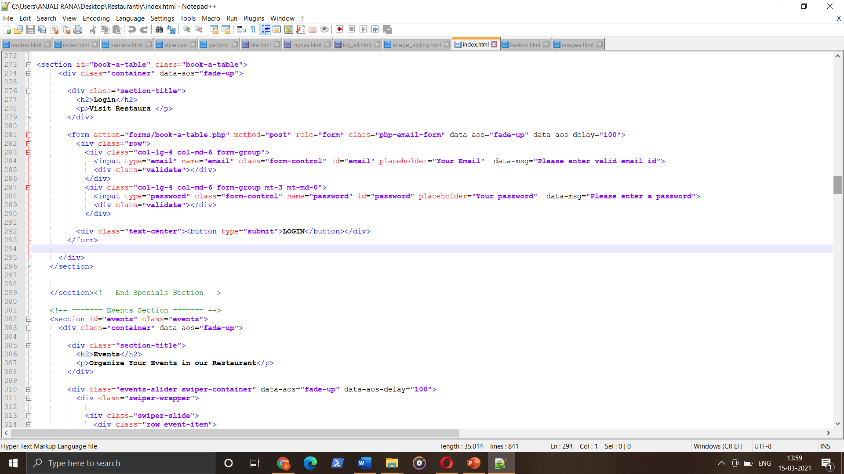

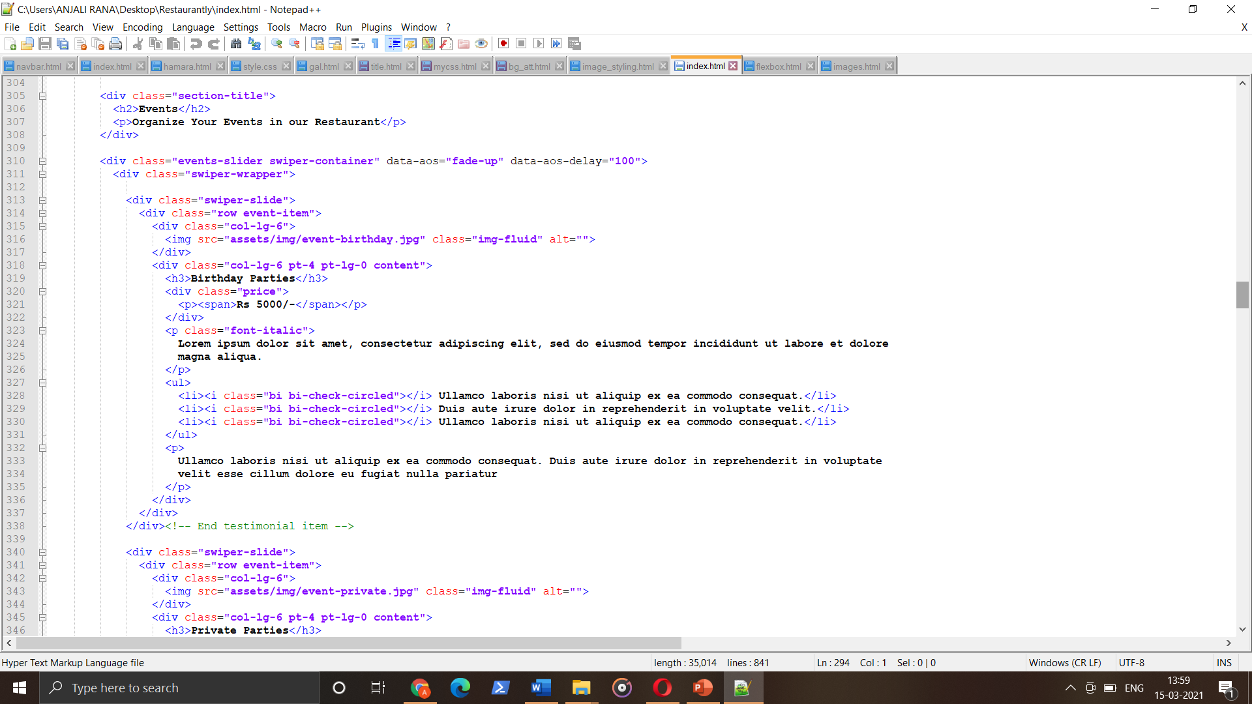

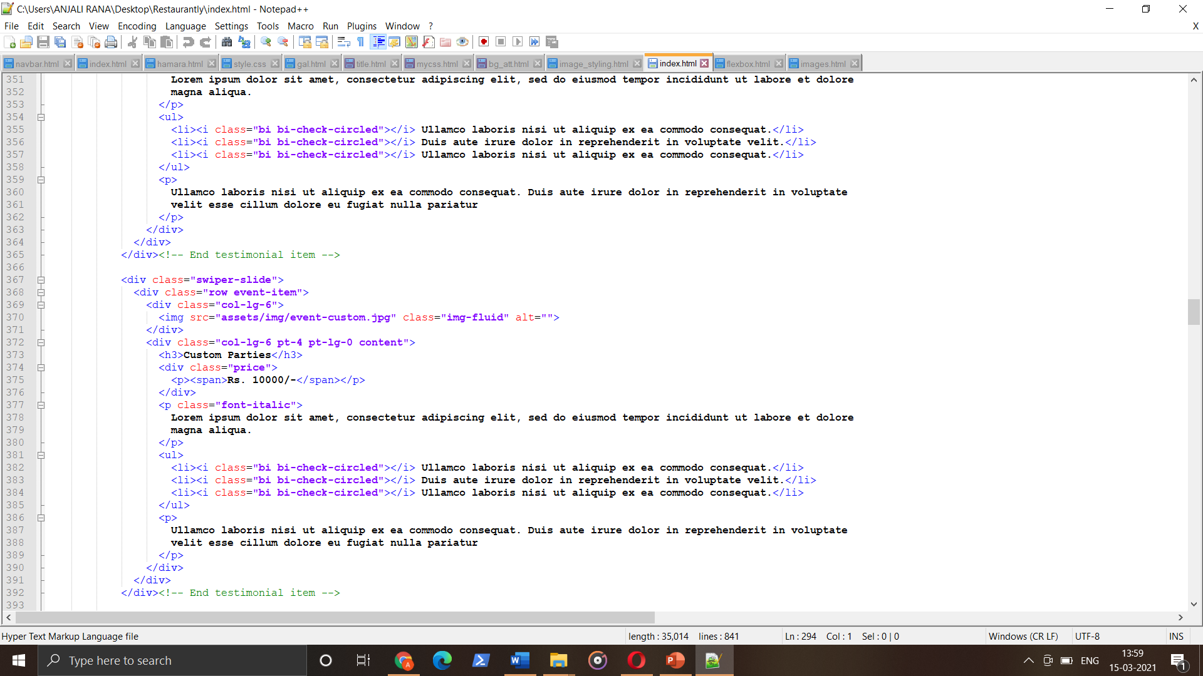

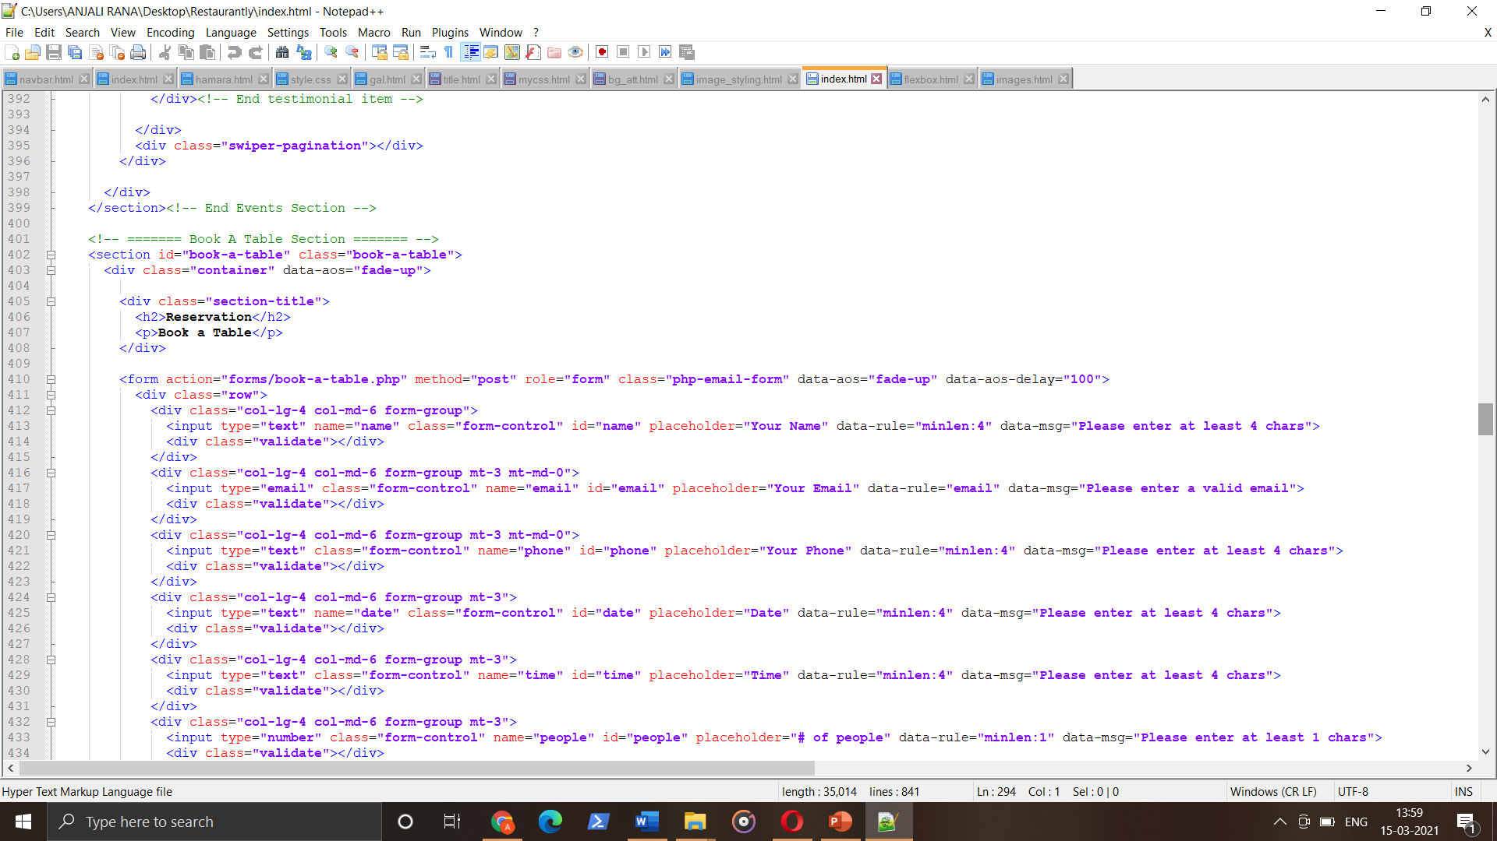

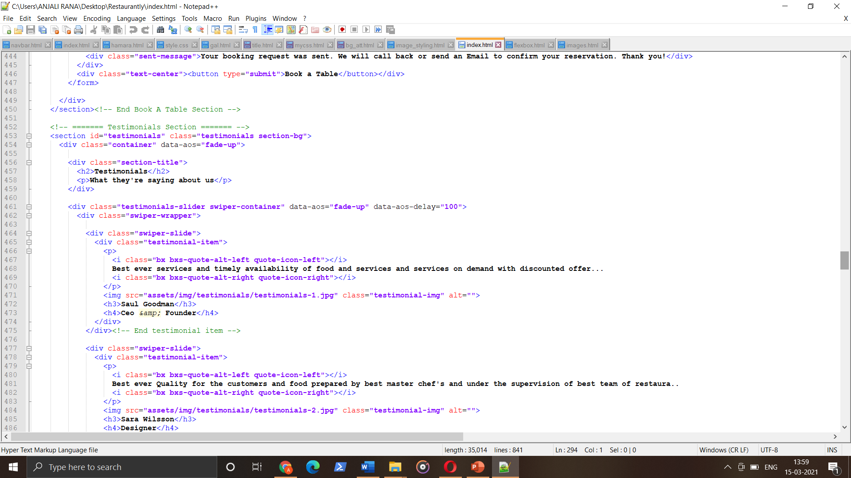

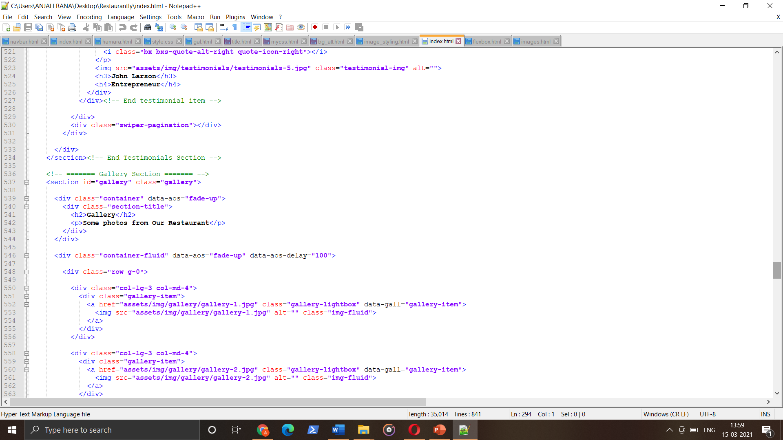

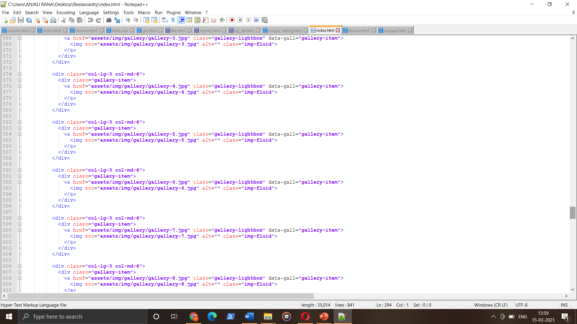

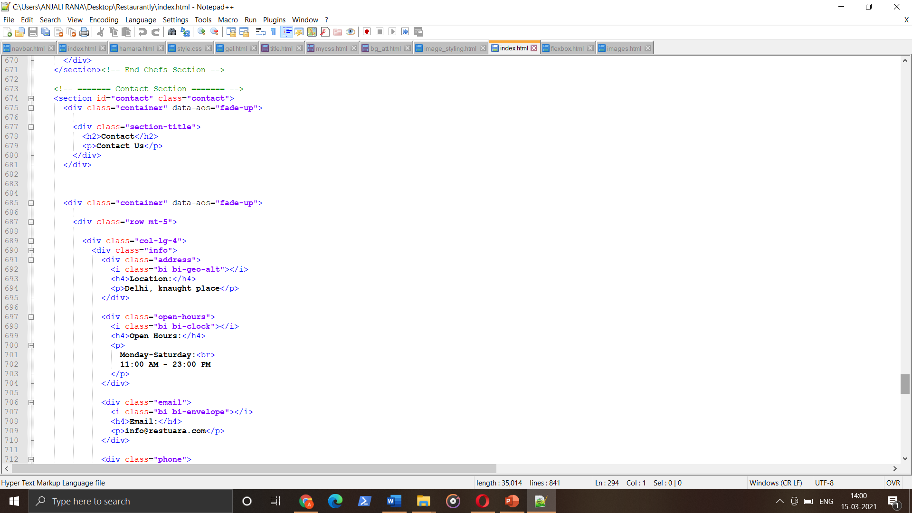

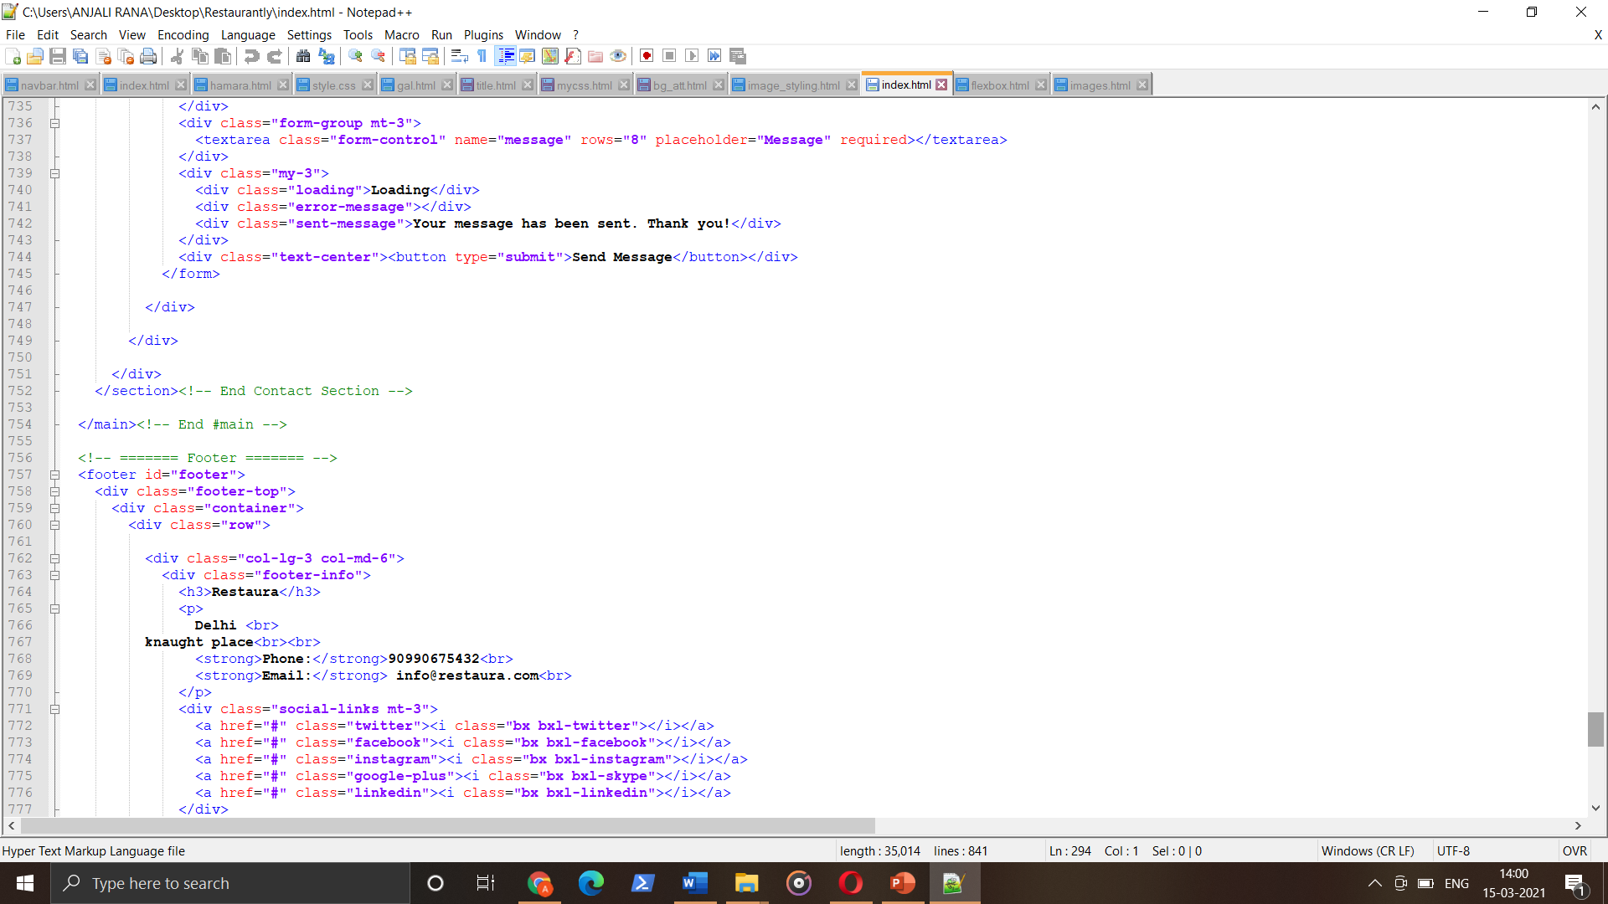

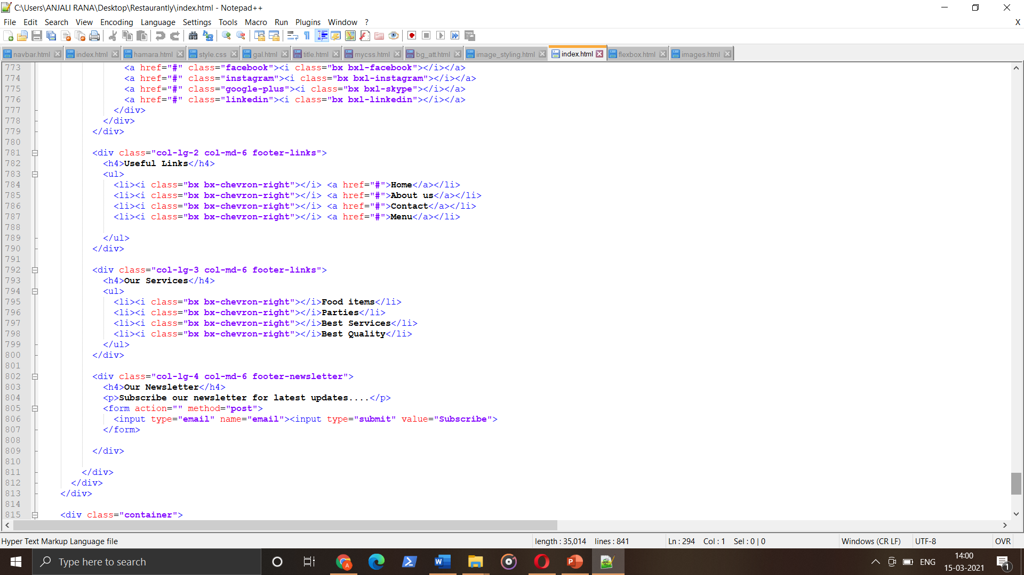

**Project screenshots:**

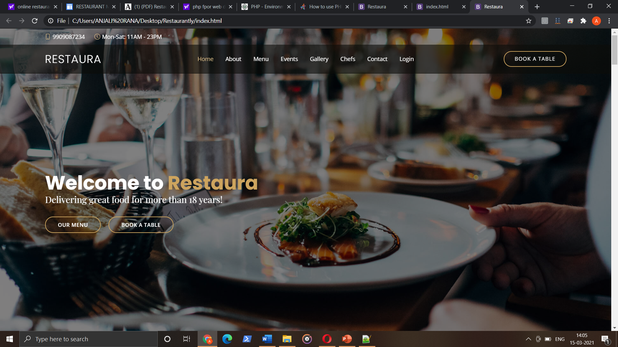

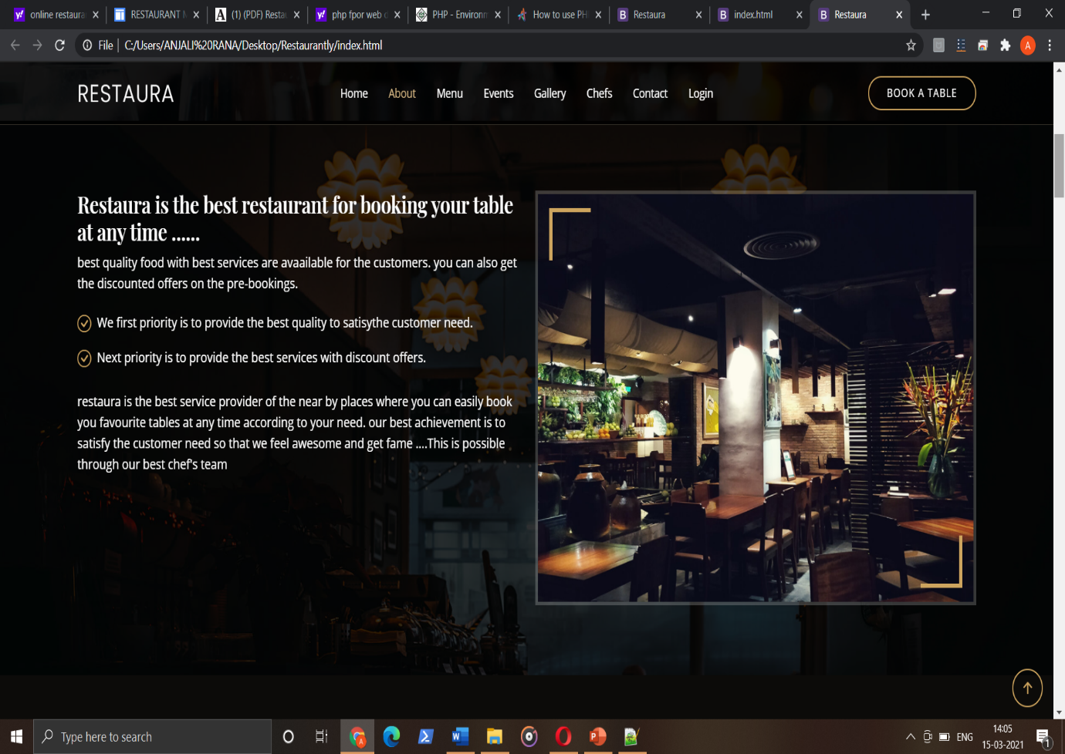

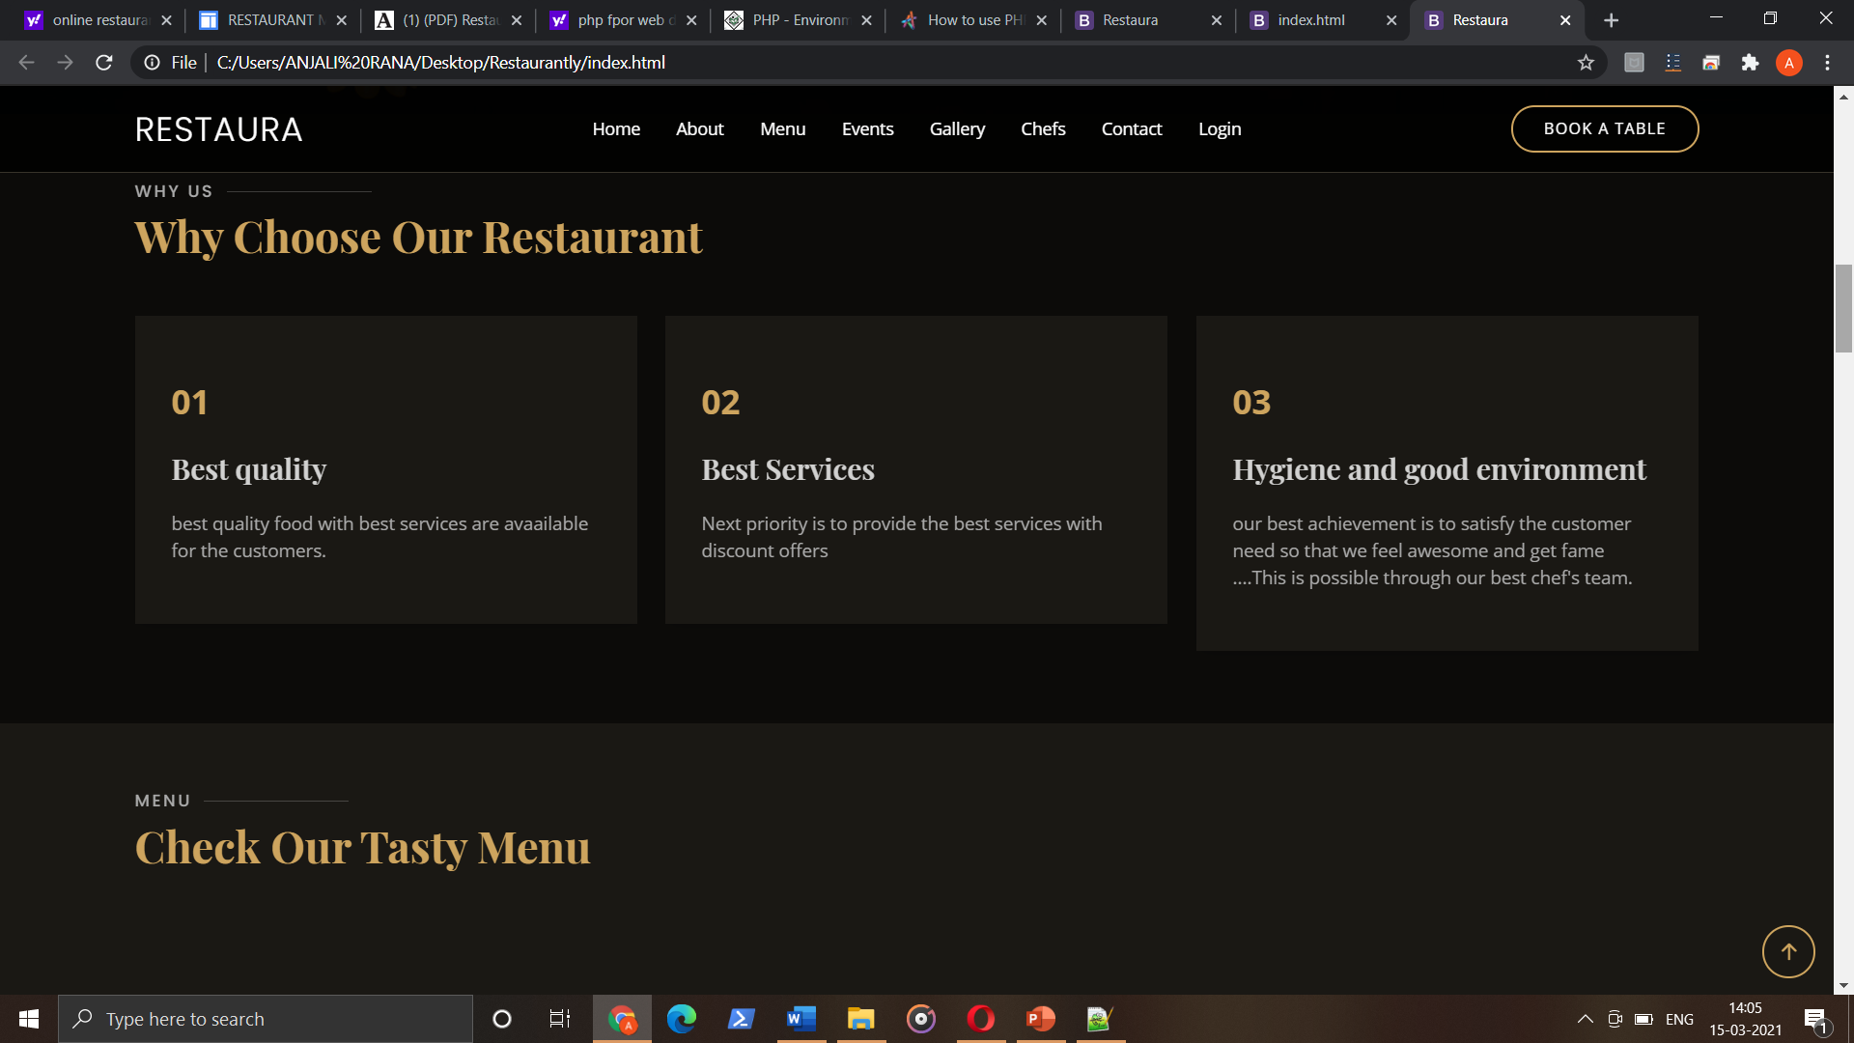

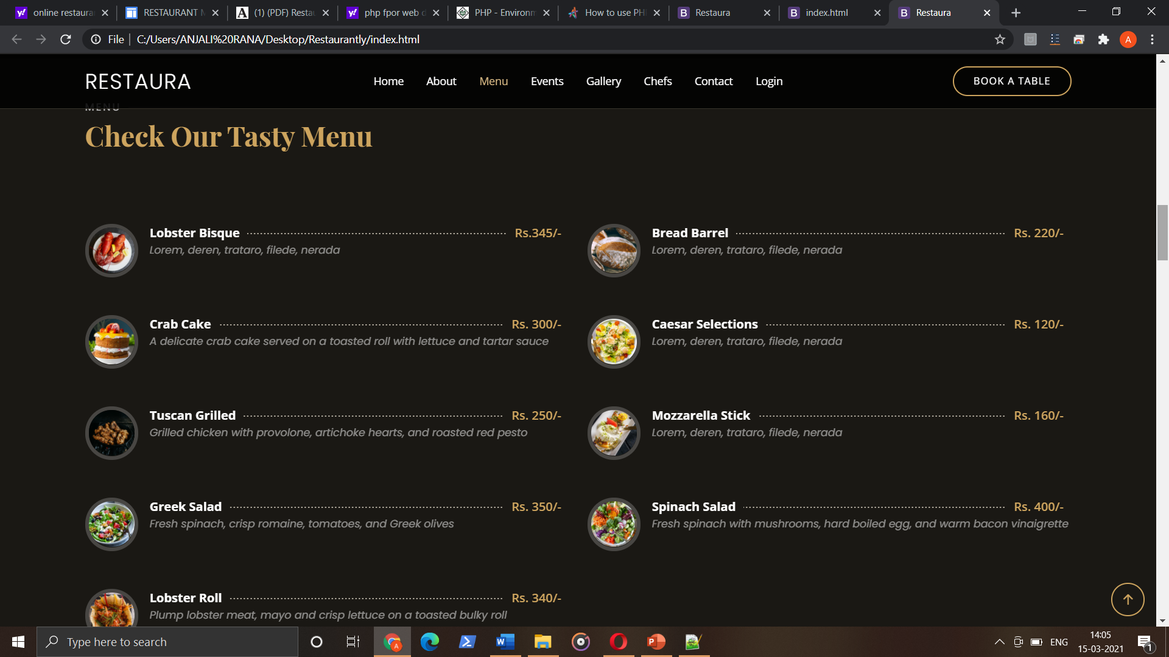

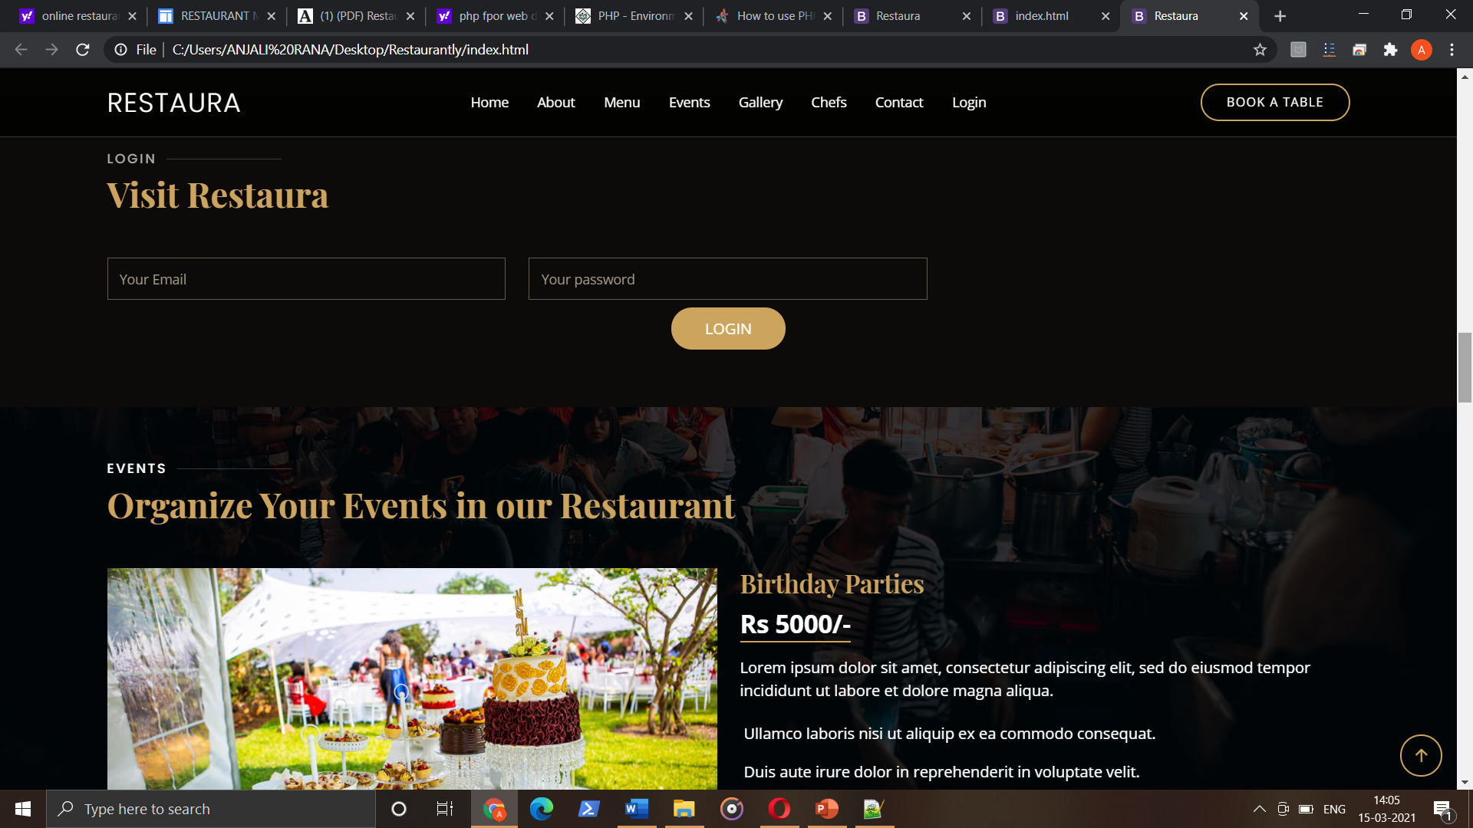

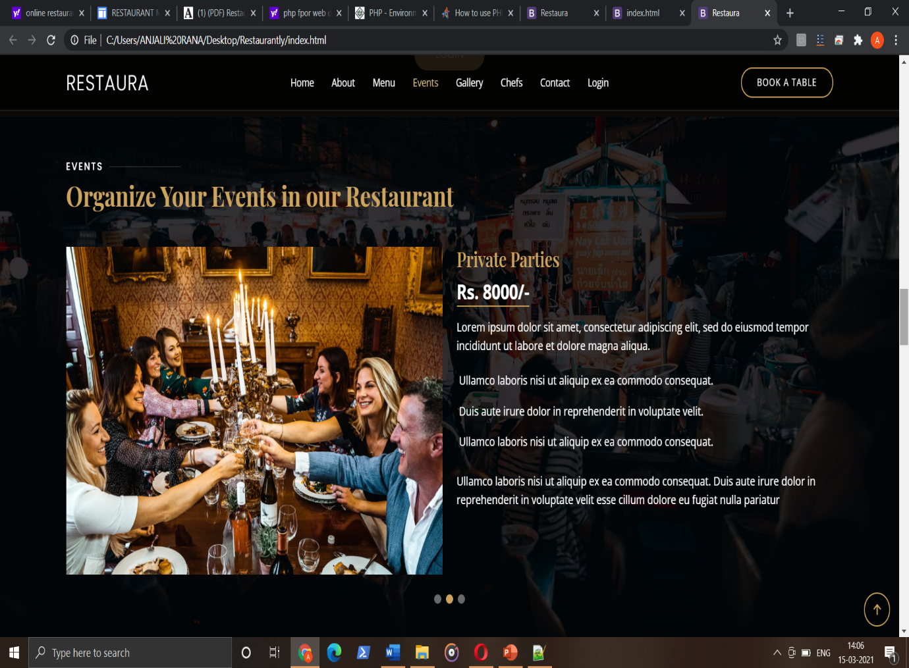

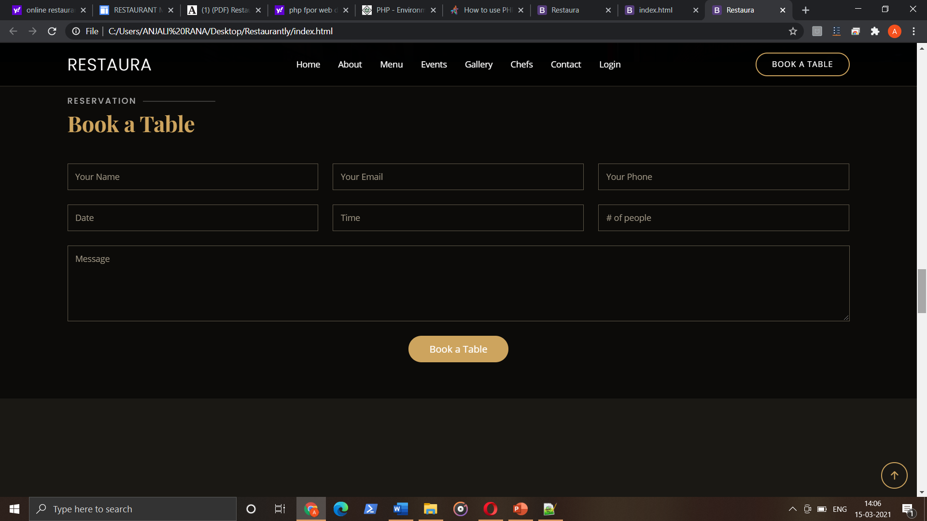

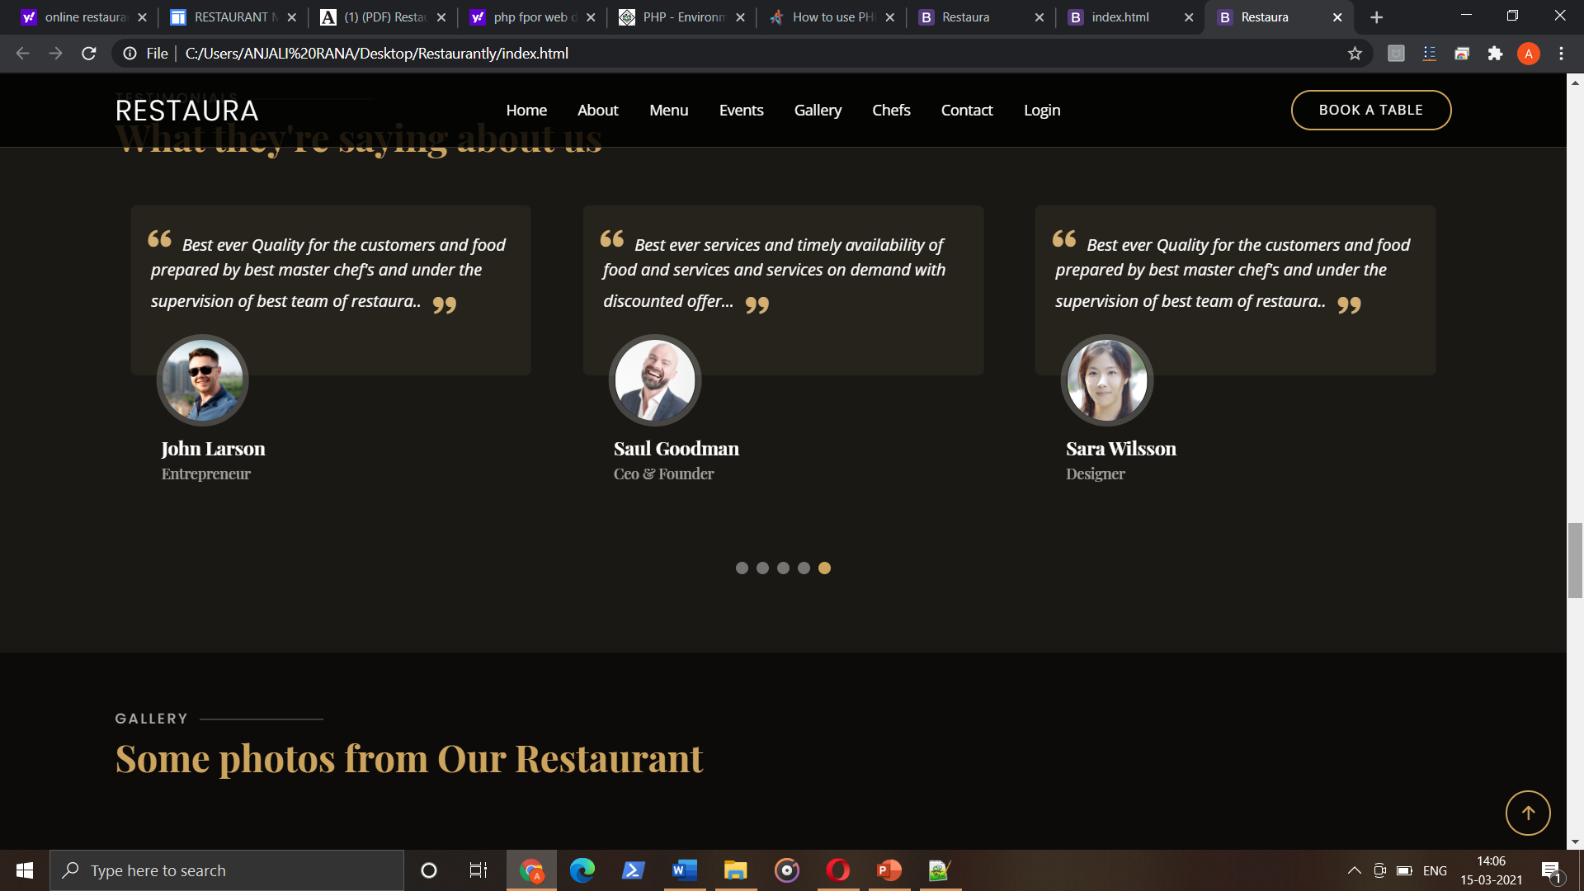

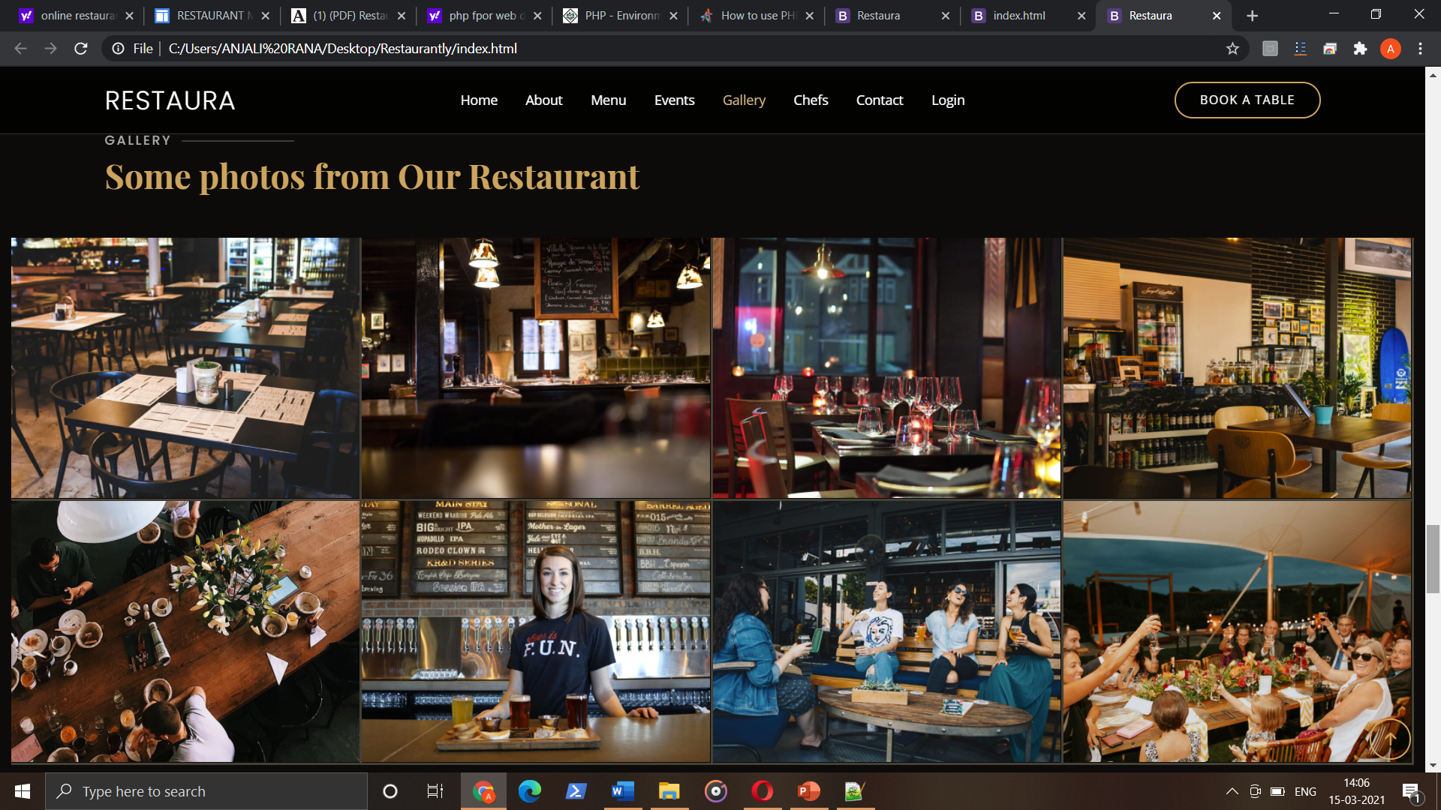

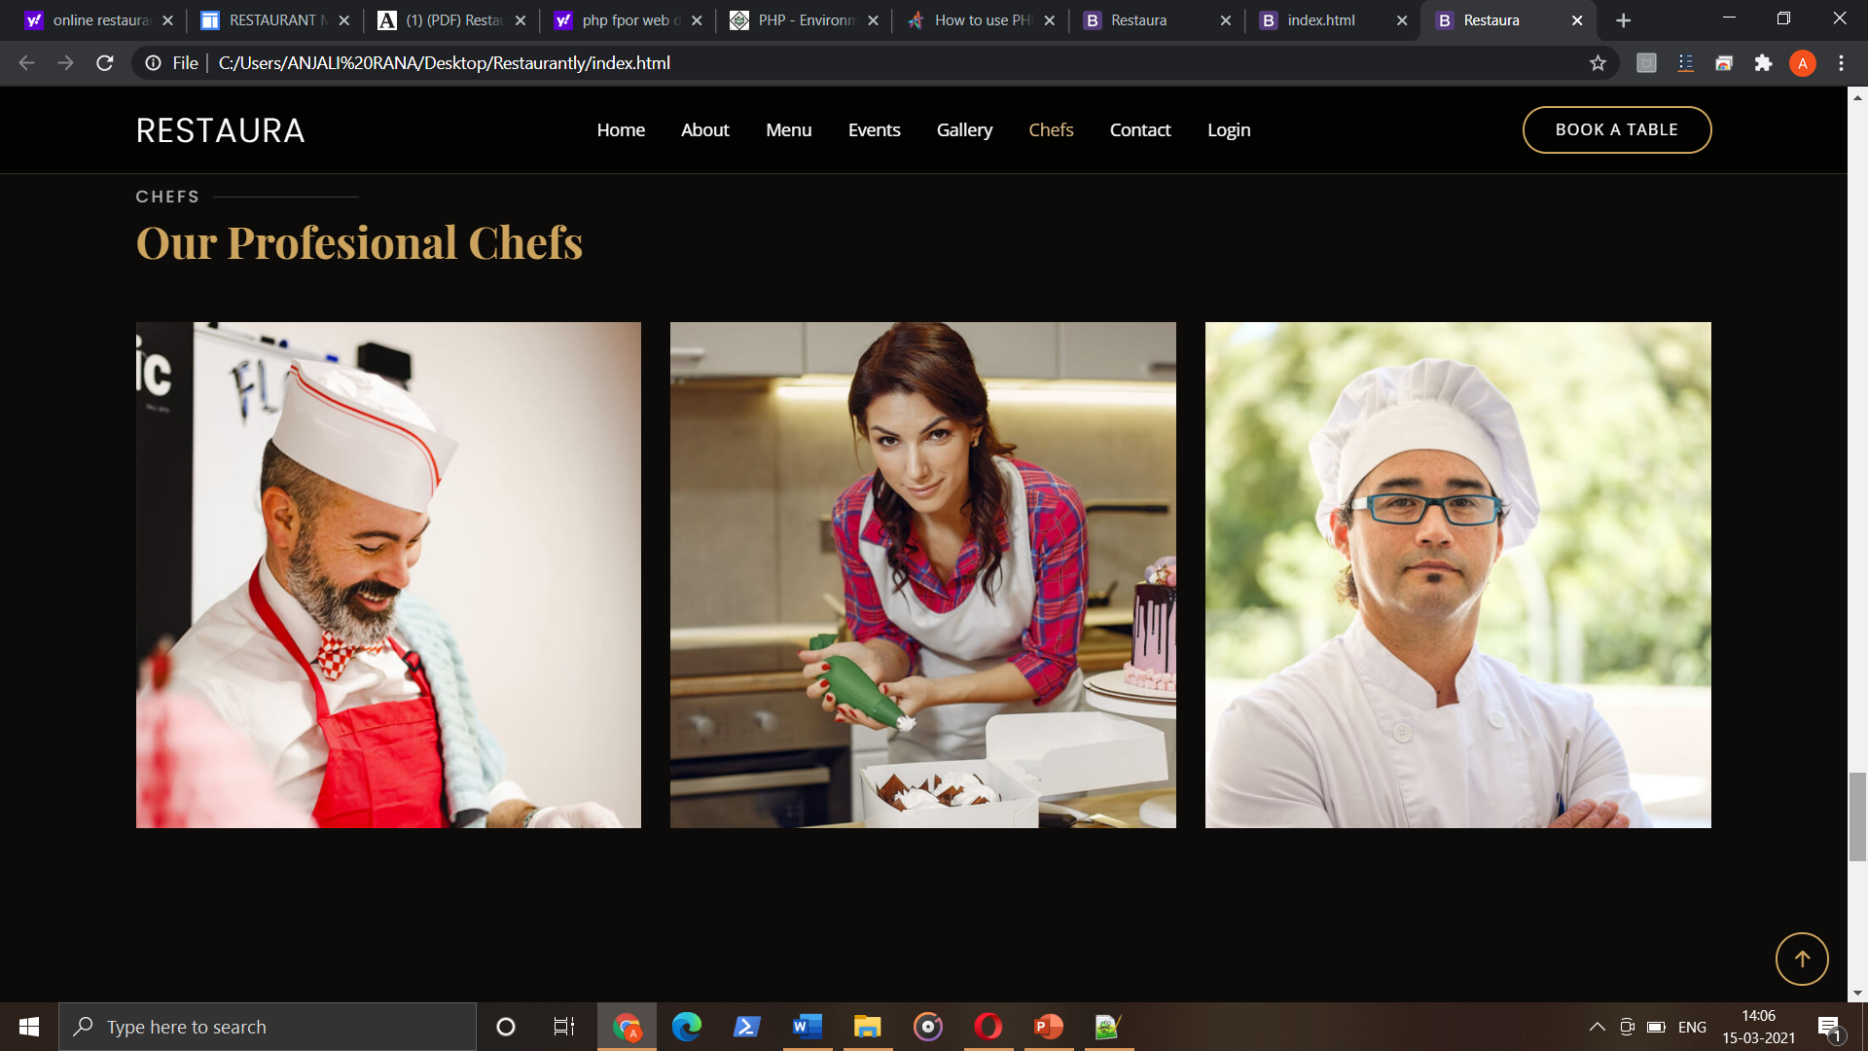

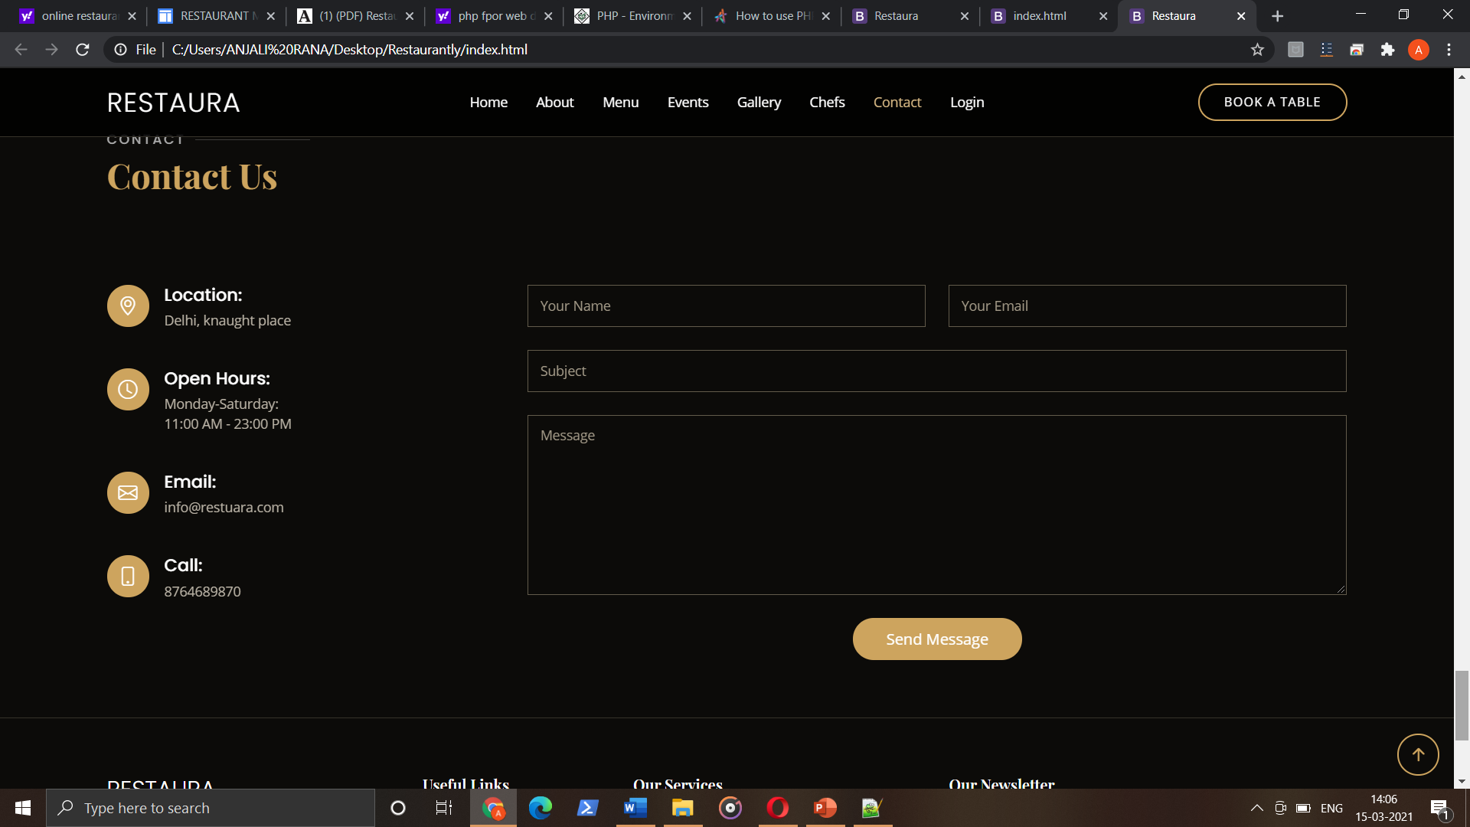

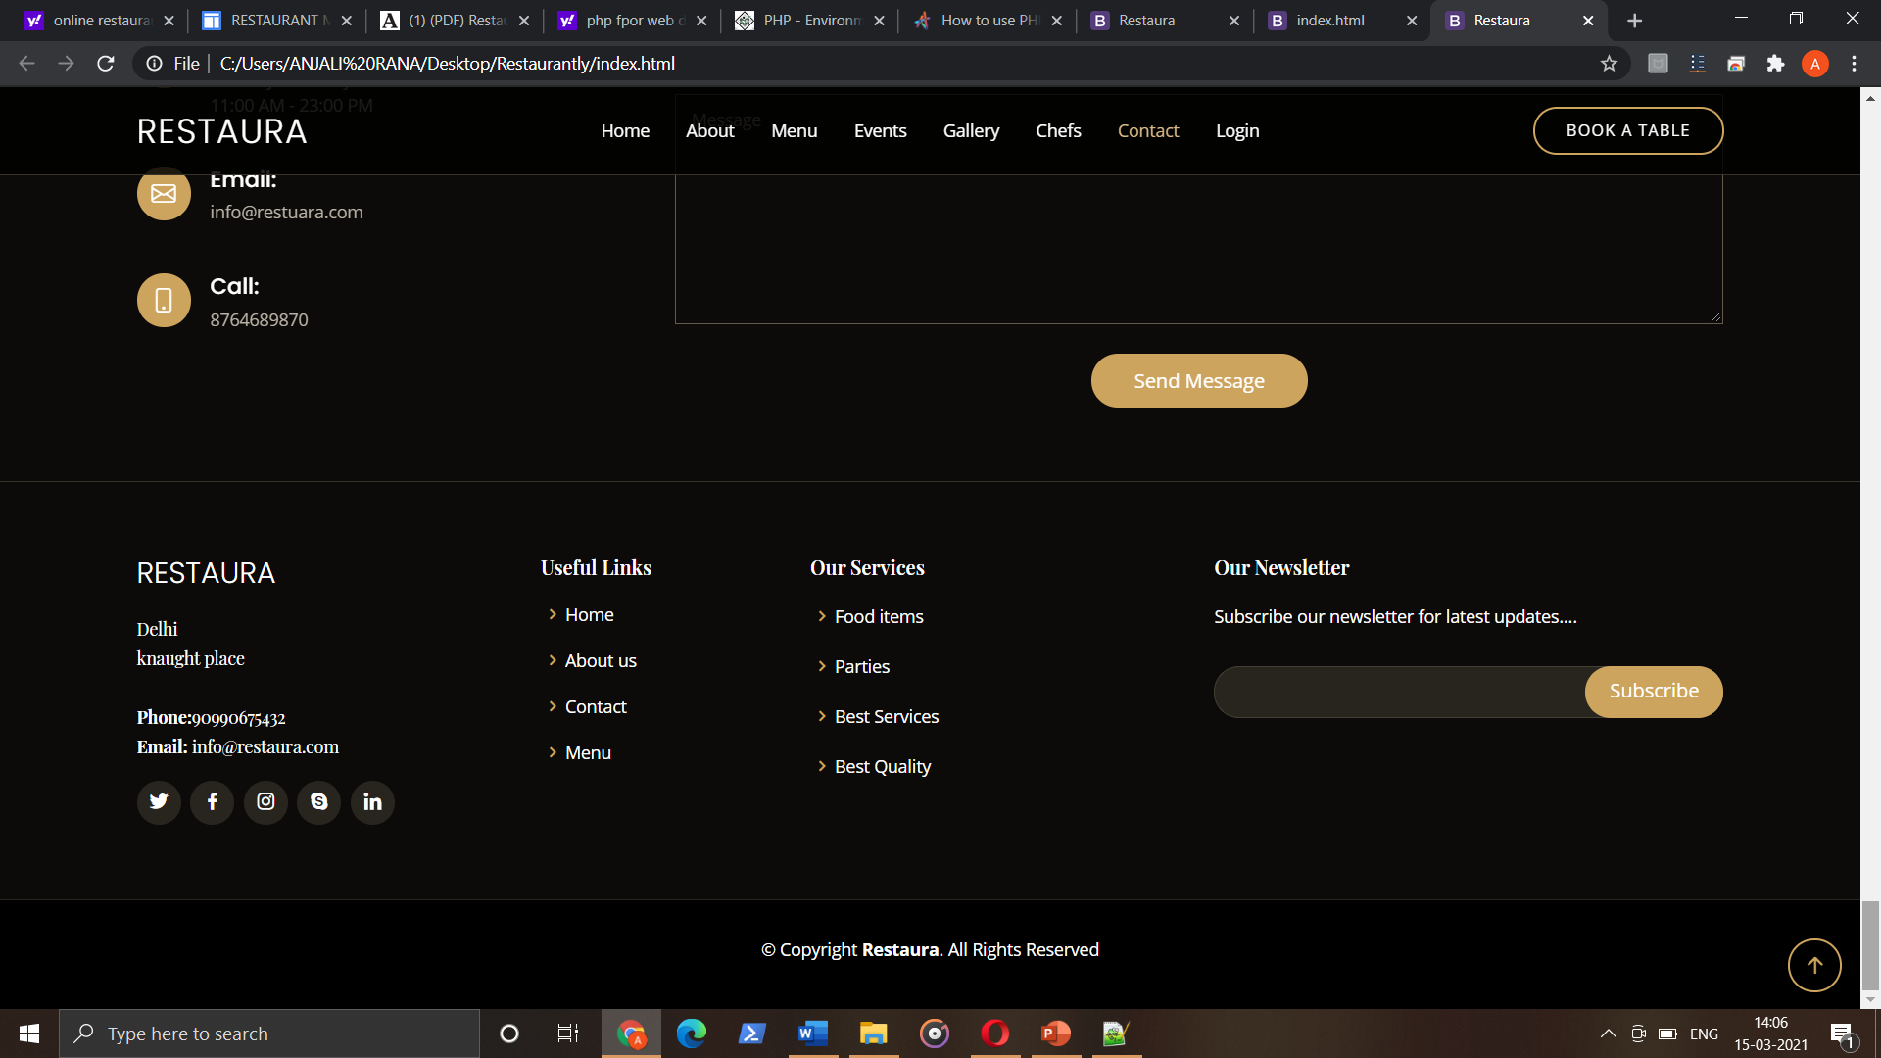

**Conclusion**

It is responsive website and it include the various categories of foods. User can book the parties like private parties, family parties and custom parties. User can also see the chefs of restaurant and see their testimonials. The services that are provided is food ordering and reservation table management by the customer through the system online, customer information management and waiter information management, menu information management and report. Main objective build the system this is to provide ordering and reservation service by online to the customer. With this system online, ordering and reservation management will become easier and systematic to replace traditional system where are still using paper.

**References:**

**1.http://www.webdevelopmentreference.com**

**2.** [**http://www.google.com**](http://www.google.com)